2020 Allied Turfgrass Research Funding Call for Proposals

Dear Turf Researchers,

This year’s allied turfgrass research funding application process, formerly known as ‘CATR’ or Canadian Allied Turf Research, is being administered by the Canadian Turfgrass Research Foundation. You are invited to apply for research project funding consideration by the following expanded group of allied turfgrass research funding organizations with a single submission:

Alberta Turfgrass Research Foundation
Atlantic Golf Superintendents Association
Canadian Turfgrass Research Foundation
Manitoba Golf Superintendents Association
Northwest Turfgrass Association
Ontario Turfgrass Research Foundation
Ottawa Valley Turfgrass Research Foundation
Quebec Turfgrass Research Foundation
Saskatchewan Turfgrass Association
Western Canada Turfgrass Association

To be considered for funding, please complete the 2020 Research Grant ‘ONECALL’ application form and return to executive.secretary@turfresearchcanada.ca by Tuesday, October 15th, 2019 by 5:00pm Pacific time.

Please get in touch with the CTRF if we have not acknowledged receipt of your application within 2 weeks of submission. While the CTRF is administering this application process, individual organizations will make funding decisions based on their own priorities, funds available, previous commitments, etc. As a result, funding for individual projects may be provided by one or more funding group.

If you have questions, please contact me at executive.secretary@turfresearchcanada.ca.

Jerry Rousseau
CTRF Executive Secretary
www.turfresearchcanada.ca
2020 Research Grant ‘ONECALL’

Complete and submit this form for project funding consideration commencing March 2020 through the following allied turf research funding organizations:

Canadian Turfgrass Research Foundation
Alberta Turfgrass Research Foundation
Atlantic Golf Superintendents Association
Manitoba Golf Superintendents Association
Northwest Turfgrass Association
Ontario Turfgrass Research Foundation
Ottawa Valley Turfgrass Research Foundation
Quebec Turfgrass Research Foundation
Saskatchewan Turfgrass Association
Western Canada Turfgrass Association

Application submission deadline – October 15, 2019

Send completed applications to executive.secretary@turfresearchcanada.ca
Notes:
- Please get in touch with the CTRF if we have not acknowledged receipt of your application within 2 weeks of submission.
- While the CTRF is administering this application process, individual organizations will make funding decisions based on their own priorities, funds available, previous commitments, etc. As a result, funding for individual projects may be provided by one or more funding group.

Application
For Internal Use Only
Date Received ______________Proposal # __________
Reviewed by Funding Partners________________________
Approved Project # ______________ Not Approved_____

Project Title:
Principal Investigator:
Applicant (If different from above):
Name of Research Facility & Department:

Project Summary
Project Length (years) | Start Date | End Date:
Project Summary – In 4-5 sentences maximum and in layman’s terms only, describe the research and how the results may impact the turfgrass industry and/or benefit the public):

Check off one or more research priorities that best fit the project:
A systems approach to sustainable turfgrass management.
Turf management best practices.
Effects of climate change on turfgrass and pests.
Improved turfgrass species and varieties.
Societal benefits of turfgrass.
Economic impact of turf management decisions.
New instrumentation, robotics and software technologies.
Basic research (economics, environment, playability) of synthetic turf & comparison to natural turf.
Development and evaluation of effective alternatives to conventional pesticides.
Nutrient management and nutrient sources.
Water conservation and water quality.
Emerging Pests – Improved diagnostics for new pests and turf diseases in northern climates.
Wear tolerance, management and recovery.

PROJECT DETails
- Describe the rationale and background of the project (half page maximum):

2. What are the potential benefits to turfgrass management? To the public/users?

3. Will the project be conducted as part of a larger project, perhaps in collaboration with another researcher, department or institution? If so, describe.
4. Will the research support the development of a commercial product (i.e., pest control product, fertilizer, equipment, turfgrass technology)? If so, describe the product and disclose if a company is involved in development.

5. List the overall objectives for your project. In addition, estimate the measurable milestones and timelines to complete each objective.

OBJECTIVE 1
OBJECTIVE 2
6. Describe the methodology to be used to achieve the objectives:
Objective 1 Methodology:
Objective 2 Methodology:
7. Describe the expected deliverables of this project:

8. Summarize how the results will be shared such as scientific publications, websites, conference presentations, etc:

9. Outline potential delays that could prevent the project from reaching the objectives or completion date:

‘ONECALL’ Funding Request
 | Year 1 ($) | Year 2 ($) | Year_ ($) | Projected Funding
Salaries and stipends
Facility and lab fees
Supplies
Travel and communication
Institutional overhead charges
TOTALS

If you have other funding sources for this project, list them below. If it is unsecured, indicate the expected funding decision date in the ‘Secured’ column, ie. NO – Aug 4, 2020
Funding Source | Cash or In-Kind amount ($) | Secured (yes/no)

TOTAL PROJECT BUDGET
* must equal total OneCall budget plus other funding source(s) budget
Estimated TOTAL Project Expenses | Year 1($) | Year 2($) | Year_($) | Total Project Cost ($)
Salaries and stipends
Facility and lab fees
Supplies
Travel and communication
Institutional overhead charges
Totals

APPLICANT INFORMATION

Mailing Address -Street
City: |  | Province/State: | Postal Code:
Phone:

E-mail:

Website Address( if applicable)

Please indicate what best describes your primary research area: | Pathology Plant Nutrition  Entomology Education  Environmental  Other (please outline): __________________
1. As the principal investigator, briefly highlight the major skills and experience that demonstrate the ability to complete the project within the timeframe allotted. Please attach one page curriculum vitae.

2. Provide a brief background of your research facility (department):

3. List any partners or collaborators involved with this project and briefly describe their functions and qualifications.
4. If the project involves the training of students, indicate the level of degree to be obtained and outline their involvement with the project.

PRIVACY & Acknowledgement

Privacy:
Applicant acknowledges that Information held by any of the allied funding organizations may be required to be disclosed to third parties pursuant to the provisions of the Freedom of Information and Protection of Privacy Act.
Acknowledgement:
By submitting this application the Applicant acknowledges and agrees that:
- All information disclosed in this application to be true to the best of the applicant’s knowledge;
- The Funding Partner may impose terms and conditions related to its approval;
- The decision of Funding Partner is final and binding on the Applicant
- The Applicant has disclosed all other sources of funding applied for and/or confirmed for the project;
- If funding is approved, the Applicant shall enter into a project agreement with the Funding Partner incorporating any terms and conditions imposed by the Funding Partner;
- Applicants, their principals and partners, consent to having their names, funding amounts and short summaries of their projects and results made available to the public.

Certification:
The Applicant hereby certifies to the Funding Partner that the application and supporting documentation are true and complete in all respects and that the person signing on behalf of the Applicant has read and understood the Privacy and Acknowledgement clauses.

 | Signature: | Date:
 | Position: | Co- applicant Signature:  (if applicable)

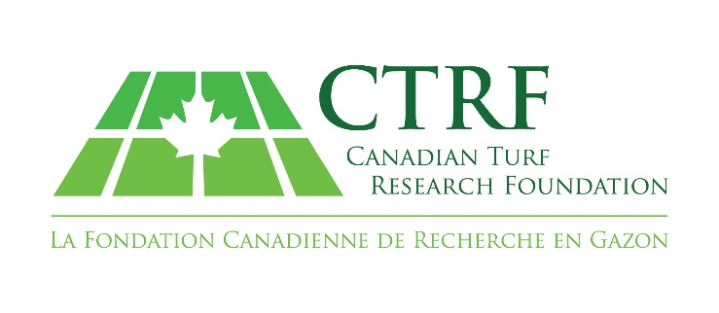

Box 698, Hope, British Columbia V0X 1L0
(604) 869-9282
Executive.secretary@turfresearchcanada.ca

Registered Charitable Foundation #0489997-03-13 Foundation de bienfaisance enregistrée

